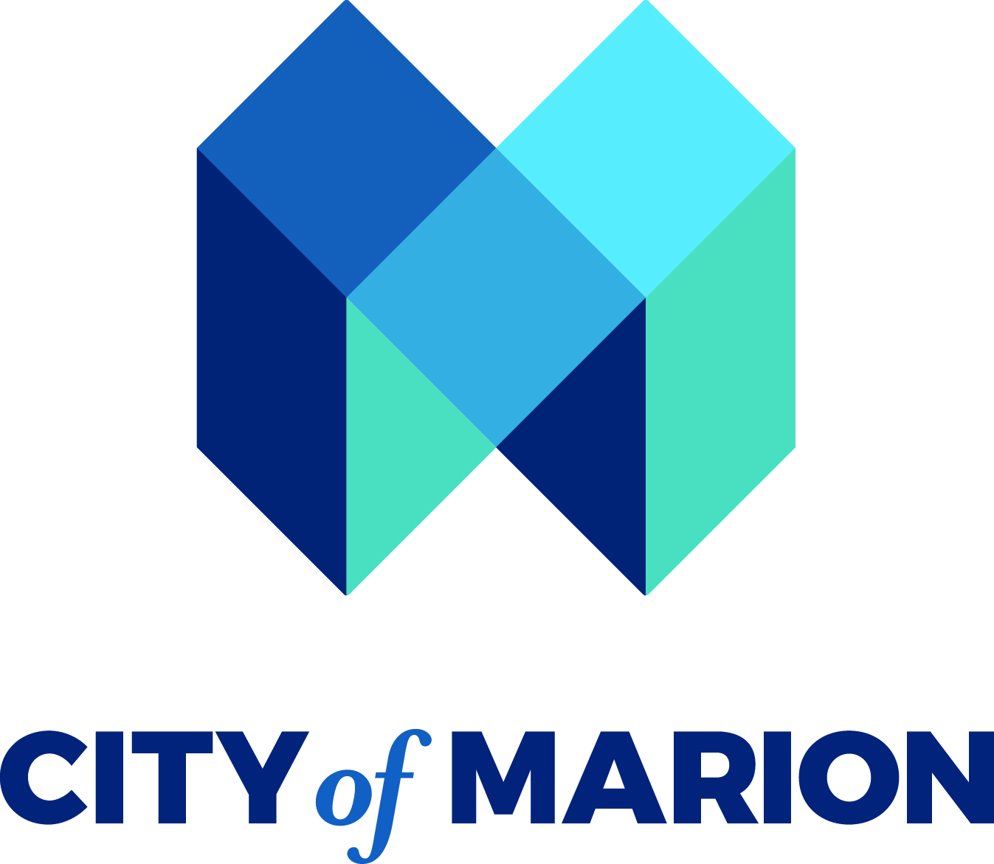

The opioid crisis continues to significantly impact our community through addiction and overdoses. This additional appropriation will allow us to support our programs and services dedicated to combating opioid addiction.

Dr. Jayda Monteiro will provide further details on this topic.

