ADDITIONAL APPROPRIATION PUBLIC NOTICE
The Tippecanoe Township Board will convene after 6:30 pm on October 14, 2026, at the North Webster Community Center, 301 N Main St, regarding ADDITIONAL APPROPRIATIONS for the following funds:

Amount Requested
0101 Township General
Major Budget Classification:
4B Capital Outlays $150,000
Total for Township General: $150,000

8604 Fire Territory General
Major Budget Classification:
2D Vehicles and Maintenance $40,000
Total for Fire Territory General: $40,000

Submitted on this 14th day of September 2026,
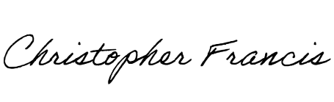
Christopher M. Francis
Tippecanoe Township Trustee

