ADDITIONAL APPROPRIATION PUBLIC NOTICE
The Tippecanoe Township Board will convene after 6:30 pm on November 11, 2026, at the North Webster Community Center, 301 N Main St, regarding ADDITIONAL APPROPRIATIONS for the following funds:

Amount Requested

8604 Fire Territory General
Major Budget Classification:
1A Salaries $100,000
Total for Fire Territory General: $100,000

Submitted on this 14th day of October 2026,
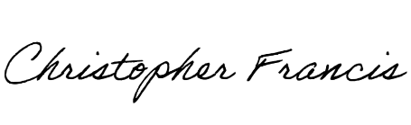
Christopher M. Francis
Tippecanoe Township Trustee

