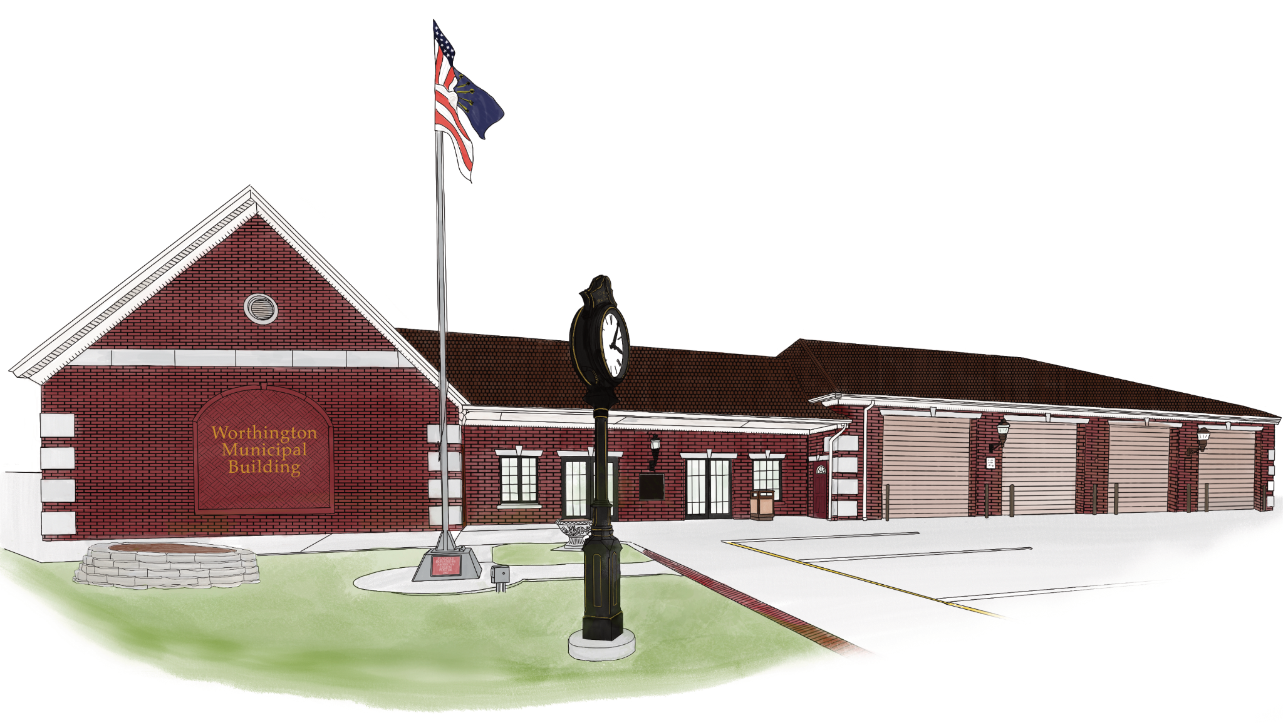

Town of Worthington Clerk-Treasurer
Matthew W. Baker
Email – clerktreasurer@townofworthington.in.gov
Worthington, IN 47471
Ph: 812-875-2641

Legal # 2026-01
Notice to taxpayers of proposed additional appropriations.
Notice is hereby given to taxpayers of Worthington, Indiana that the
proper legal officers of the Worthington Town Council at their regular
meeting place at the Town Hall, at 6:00 p.m. on the 10th day of February
2026, will consider the following additional appropriation in excess of the
Budget for the current year.

Name of Fund Amount
General Fund
1101-001-315 – Misc. Expenses $10,000.00
Total for General Fund $10,000.00

Taxpayers appearing at the meeting shall have a right to be heard. The
additional appropriations as finally made will be referred to the Department
of Local Government Finance. In most cases, the Department of Local
Government Finance will make written determination as to the sufficiency
of funds to support the appropriations made within fifteen (15) days of
receipt of a certified copy of the action taken.
Matthew W. Baker, officer of taxing unit.

